Sunday | Monday | Tuesday | Wednesday | Thursday | Friday | Saturday
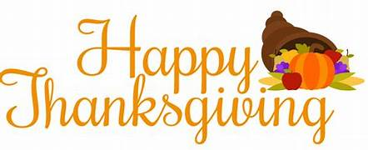 |  |  |  |  | 1 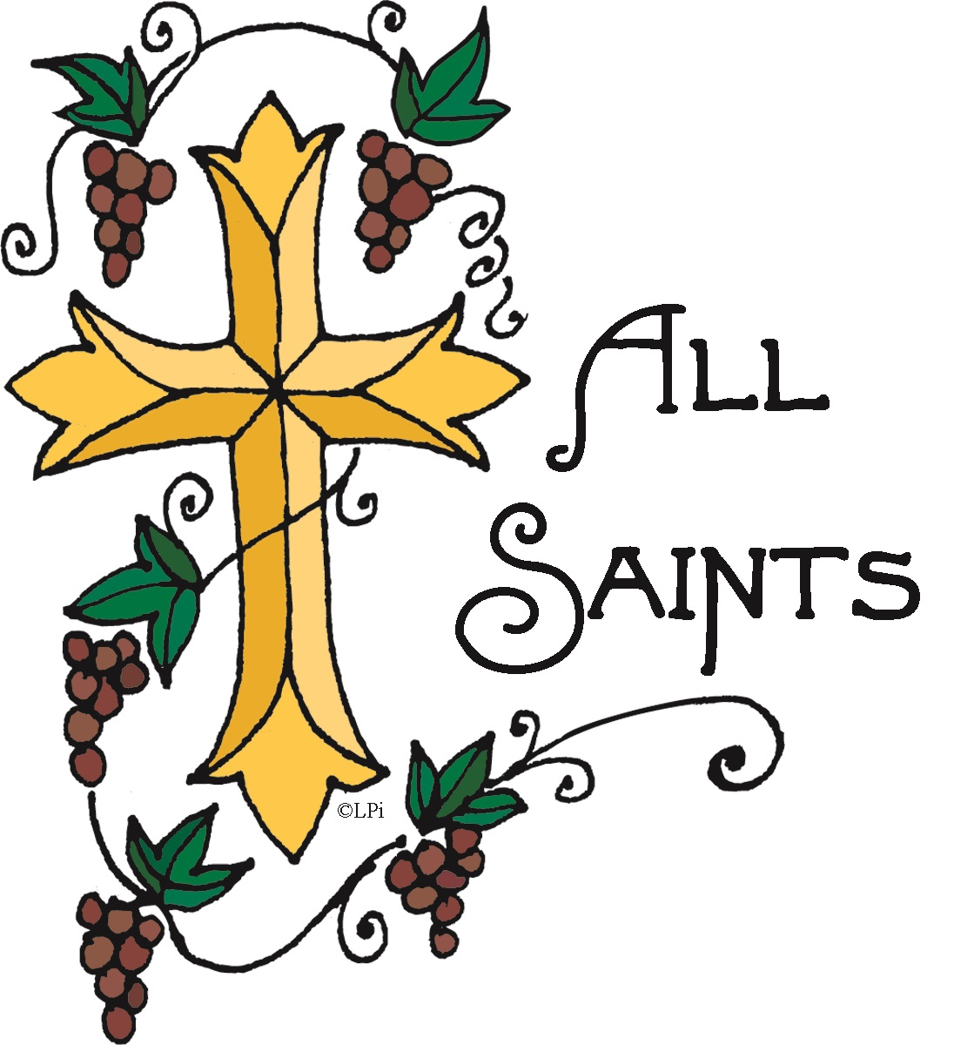 | 2 Eve of All Saints  Sunday  3:00-Harris Baptisms  5:00-Word and Sacrament  Worship in Sanctuary  Vicar Intern Harford  TURN CLOCKS BACK
3 All Saints Sunday  11:00-Word and Sacrament  Vicar Intern Harford  Noon-Martin’s Soup &  Cider | 4  11:00–Staff Meeting  11:45-Commmunion  12-Prayer Meeting. | 5  6:30-Bible Study  6:30 – Bell Choir | 6  7:00-Property | 7 | 8 | 9 Eve of Pentecost 24  5:00- Word and Sacrament  Vicar Intern Harford
10 Pentecost 24  10:45-Sunday School  11:00- Word and Sacrament  Vicar Intern Harford  Noon-Hospitality | 11  11:00–Staff Meeting  11:45-Commmunion  12-Prayer Meeting. | 12  6:30 – Bell Choir | 13  5:30-Council | 14  7-By the Heart Bible  Study-First | 15 | 16 Eve of Pentecost 25  5:00- Word and Sacrament  Vicar Intern Harford  Congregational Meeting  Before worship
17 Pentecost 26  10:45-Sunday School  11:00- Word and Sacrament  Vicar Intern Harford  Noon-Hospitality  Congregational Meeting  Following worship | 18  11:00–Staff Meeting  11:45-Commmunion  12-Prayer Meeting. | 19  VSJ Deadline  6:30 – Bell Choir  6:30-Bible Study | 20  11:00-Tower  Moments | 21  7-By the Heart  Bible Study  Benscreek | 22 | 23 Eve of Christ the King  5:00- Word and Sacrament  Vicar Intern Harford
24 Christ the King  10:45-Sunday School  11:00- Word and Sacrament  Vicar Intern Harford  Noon-Hospitality | 25  11:00–Staff Meeting  11:45-Commmunion  12-Prayer Meeting. | 26  5:00-New Day Thanksgiving Dinner  6:30 – Bell Choir | 27 | 28  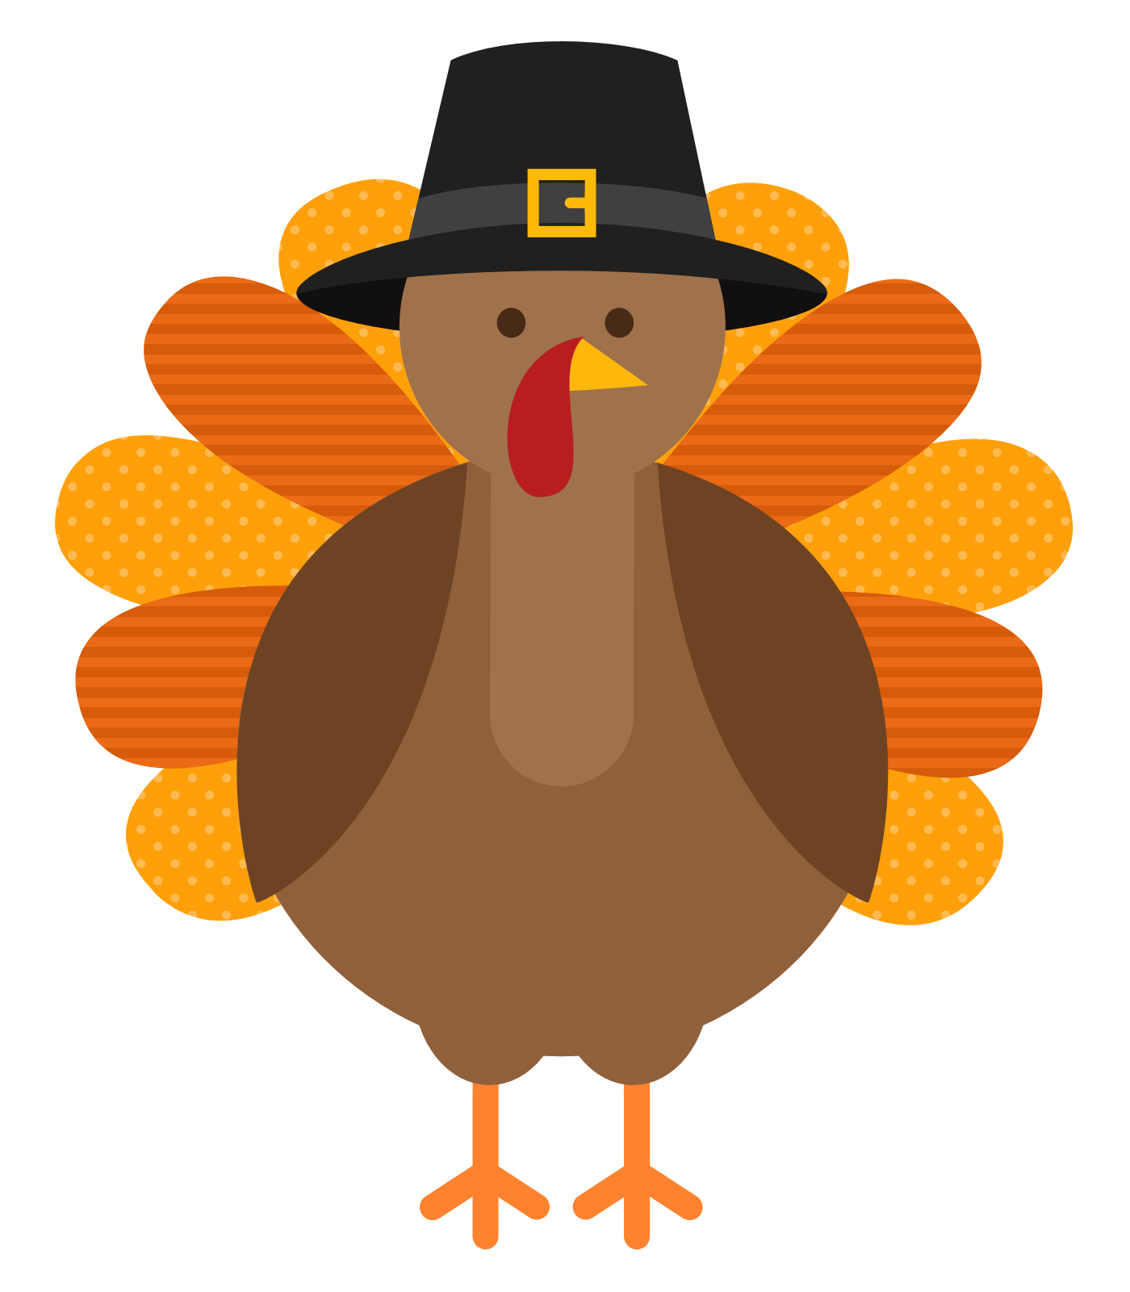 | 29 | 30
xxxx

lmlml mmmmm
Rejoice in hope, be patient in tribulation, be constant in prayer. ~ Romans 12:12

November 2024
First Evangelical Lutheran Church – Johnstown, Pennsylvania
814-536-7521 email: firstlutheran@wpia.net
Office Hours: Mon. thru Fri. 9 am – 2:00 pm

